KIGALI INDEPENDENT UNIVERSITY ULK

GISENYI CAMPUS

**B.P BOX 243 GISENYI**

SCHOLL OF SCIENCE AND TECHNOLOGY

DEPARTMENT OF COMPUTER SCIENCE

**ANALYSIS, DESIGN AND IMPLEMENTATION OF EVANGELICAL RESTORATION CHURCH**

**INFORMATION SYSTEM**

**Case Study: GOMA CITY**

A dissertation submitted to the school of Science and

Technology in partial fulfillment of the academic

Requirements for the award of Bachelor’s degree in

Computer Science.

By:

**BUTELEZI PONGA JULIENNE** and

**CHIRUZA BISIMWA GRACE**

Supervisor: **Eng. NZAYISENGA HABARUGIRA Marcellin**

**ACADEMIC YEAR: 2019 - 2020**

**DECLARATION**

“This dissertation titled**ANALYSIS, DESIGN AND IMPLEMENTATION OF EVANGELICAL RESTAURATION CHURCH INFORMATIONS SYSTEM** is our original work, it has never been submitted before for any other degree award to any other University ‟.

BUTELEZI PONGA **Julienne** RN: 201720574

Signature ………………………………………….

Date………………………. -…………-……………..

CHIRUZA BISIMWA **Grace** RN: 201720131

Signature ………………………………………….

**APPROVAL**

“This dissertation title **ANALYSIS, DESIGN AND IMPLEMENTATION OF EVANGELICAL RESTAURATION CHURCH INFORMATIONS SYSTEM** has been done under my supervision and submitted for examination with my (our) approval.

Supervisor UWANTEGE **Oliver**

Signature ………………………………………….

Date………………………. -…………-……………..

**COPYRIGHT**

Copyright Reserved by the author. The text is Copyright © 2020.

**BUTELEZI PONGA Julienne** and **CHIRUZA BISIMWA Grace** of the work. All rights Reserved. No part of this Dissertation may be reproduced or transmitted without prior written permission of the author*.*

**DEDICATION**

We dedicate this work to the creator of Earth and Heaven; our almighty God, whom allow us to made it. To our Parents **CHIRUZA BISIMWA Jean-louis; BYENGE ZABAKENGA Marie.** whose words of encouragement and push for tenacity ring in ours ears. For what they did in our lives; may the almighty God continue blessing them.

Our family’s members;

Our sisters and brothers,

Our friends.

Our beloved brothers and sisters in Jesus-Christ;

Our Colleagues and class mates and everyone who contributed to the success of our project morally; financially; scientifically and spiritually.

**ACKNOWLEDGEMENT**

The success and final outcome of this project required a lot guidance and assistance form many people and we are extremely privileged to have got this all along the completion of this project. Being at the end of our scientific work, we are extremely grateful and thankful to the Almighty God, who filled his grace and breath of life upon us by giving us good health, strength, intelligence and much more that we cannot list here in order to reach the completion of this work. We thank a lot the owner and founder of **KIGALI INDEPENDENT UNIVERSITY prof. Dr. RWIGAMBA BALINDA** for this achievements and wisdom, without forgetting all the pieces of advice and all the blessing that he has been wishing us every time that the occasion opened up. Also, we are million grateful to our Supervisor the **Engineer** and **Lecturer Oliver UWANTEGE**, who beside her overloaded schedule, despite the multitude responsibilities and work, she has accepted to take her time to provide with good remarks, guidance and correction without them we could had not reached to the completion of this scientific work. We could not draw a curtain to this part of acknowledgment without saying a word of thank to the administration staff to whom we owe almost everything because they did their best toward us, choosing and selecting best lectures and putting us in a comfortable environment that helped us to complete this present work.

We are finally so thankful to Family members, especially our parents and sponsors who have done all they could for the success of this project.

To anyone who contributed in any way to the completion of this work, accept our sincere thanks.

**LIST OF ABBREVIATION AND ACRONYMS**

ERC: Evangelical Restoration Church

SQL: Structure Query Language

PS: Photoshop

HTML: Hyper Text Markup Language

CSS: Cascading Styles Sheet

CRUD: Create Read Update Delete

**ABSTRACT**

As we are in the midst of revolution, technology has taken a high consideration by providing services at real time, this fact has simplified life of thousands of communities. Look at the revolution history; programmers have level up their skills by conceiving project on different carries such as desktop application; web application; artificial intelligence and so on. Focusing on our project, we are going to develop an Online **Evangelical Restauration Church**.

**Evangelical Restauration Church (E.R.C)** is a church having different extensions in Africa with the mission statement of winning souls for Christ. The church care for the souls of by organizing different trainings, preparation Bible teaching and equip them with the word of God for the spreading of the gospel. And the church has the vision of trained christians to be in deep communion with God no matter how situation is presented, having christians who’s totally consecrated to our lord Jesus. Through the current system,ERC use paper base system to save (record) new christians, and the management of old christians of the church. or information about departments services, and they use to put notice on wall or panel in town to call or tell people about news which takes a lot money and time. This project aimed to build a system for **Evangelical Restoration Church** which will facilitate the church to manage information. This study has three specific objectives: To develop a database that will store information related to the registered new christians, to group, classify, process and disseminate data. To create a user-friendly interface that will engage the new christian to be in touch with the church straight in the evangelical department, will display data to christians and all information about programs, services, weddings, departments in the real time. And once in the system we let the administrator to insert, update, search and deleting information and further we develop a web-based system that facilitate the user to access the church, to login, viewer news, and donate. We collected data through the interview as a data collection tool whereby we interviewed some church members of E.R.C. We provided an overviewed of how online church will facilitate christian to be aware with all new of the church once not miss church services. The method used to develop the system included prototype model approach, the use of Unified Modeling Languages (UML) that what has been used to design the system. In conclusion; the Evangelical Restauration Church information system was designed to provide information to Christians and to solve information management issues. We recommend the church ERC to use this system not only to provide information but also for recording and keeping data.

**TABLE OF CONTENT**

**CHAPTER 0: GENERAL INTRODUCTION**

**INTRODUCTION**

These days, according to the development of services and infrastructures (in case of the pandemic COVID-19), there is a lot of way church uses to reach people over the city.

Means used by church are very important for informing Christians about news and programs about church or online preaching, to keep in touch with christians and to make Christian really engaged to different news of church by providing them the Word of God and exhortations.

Restoration church information systems is a directory to provide news about the church and online sermon services and to gather all church information, in Goma town (in COVID-19).

The representation in our website of Restoration church is free for any Christians of over the world, for strongly contributes to the Christians of Goma to be informed by proposing the word of God and the Good news in real time.

Restoration church information system is a real vector of communication for any person wishing to hear the word of God in Goma town.

The first goal of Restoration church information systems is to give a website for the first interaction between Christians and church.

**PROBLEM STATEMENT**

In Goma town there is many Christians with lack of information, not because of poor church but because of lack of communication between Christians and church.

Many Christians start a spiritual life cannot develop themselves firstly because of lack of means of getting good news from the word of God, secondly because of lack of a Christian platform as means of interaction.

**HYPOTHESIS**

A hypothesis is supposition or proposed explanation made on the basis of limited evidence as a starting point for further investigation.

In the restoration church information system, the interaction between the Christian and the church is so important, but if once the drop in productivity happened because of the non-connection of the church to the Christian, how can that problem be solved?

Our system will:

* broadcast the church’s news to all the Christians
* be able to give real time information on the church’s activities
* be able to connect all the believers via a blog where they can chat, post and comment about the news and activities of the church
* be able to organize and monitor all the conversation and post of Christians with the administrative interface.

**1.4 PROJECT OBJECTIVES**

This work has two types of objectives, the general objective and the specific objectives.

**1.4.1 General Objective**

The general objective of this work is analyzing, designing and implementing a website where church news and sermons are published.

**1.4.2 Specific objectives**

The specific objectives are to:

* Develop easy locate website of restauration church in Goma town.
* Increase the number of Christians in need of the church information.
* Change the old system of reaching Christian by providing a new platform.
* Publishing church news and sermons of different church programs.
* Provide a platform for first interaction between Christians and church.

**SCOPE OF THE PROJECT**

The scope of our work is focused on restoration church information system, and will be helping Christians to find easily church information and news in Goma town. The time for our project to be done is from July to the end of the month of August.

**SCOPE IN TIME**

The present project is carried out and built in 2020 with the academic purpose of solving the problem of Information management of the Evangelical Restauration church System and information spreading.

**SCOPE IN SPACE**

Our study which is about ”**Analysis, Design and Implementation of Evangelical Restauration Church Information System**”was carried at” EVANGELICAL RESTAURATION CHURCH”**; (E.R.C),** located in GOMA TOWN, North Kivu province in the Democratic Republic of Congo (DRC).

**Significance of Study**

Let’s mention that that this project was not chosen randomly, we chose I t with interest of improving the way of tracking data.

PROJECT METHODOLOGY

For our project, data collection techniques and methodology will be used to make a good work.

* + 1. **Data collection technique**
* Documentation technique

The documentation method will be used for data collection. Websites with the same purpose and books will support us to carry out this project.

* **Observation technique**

For helping us to do useful work, the observation method will be used get information and data.

We will be doing a distinct observation for helping us to know to the weakness of businesses for reaching people and also to provide a good work.

* **Interview**

For completing this work, a daily meeting of customers in need of different services will be interviewed to help us to get their need, and also for helping us to develop to answer to their problem.

The same will be used for owners of businesses but differently for getting different perception of the problem.

**1.6.2 System analysis and design method**

For our project we will be using the structured system analysis design method (SSADM) which is a set of standards for systems analysis and application design that uses a formal methodical

approach to the analysis and design of information systems. we will be using it to specify functional and nonfunctional requirement.

**1.7. PROJECT SCHEDULE**

Project scheduling is a mechanism to communicate what tasks need to get done and which organizational resources will be allocated to complete those tasks in what timeframe. A project schedule is a document collecting all the work needed to deliver the project on time.

A project is made up of many tasks, and each task is given a start and end (or due date), so it can be completed on time.

To accomplish our work, we will be using the waterfall model development methodology and we will pass through following stages:

* System study
* System analysis
* System design
* Programming
* Testing
* Implementation
* Maintenance

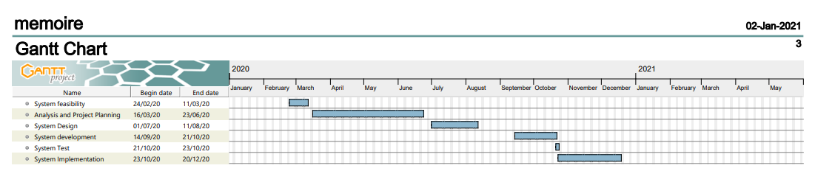

**Figure 3.Gantt chart for the project**

**1.8 ORGANIZATION OF THE PROJECT**

We will do ours work basing on five following chapters:

**Chapter 1: General introduction.**

In this chapter we will be giving a general view of the project, we will be talking about the main objectives, methodologies used and the scope of our project.

**Chapter 2: Literature review**

In this chapter we will be showing measures used for getting answer to the problem and will help us to know the existing problems and the way to avoid them.

This chapter covers theories and literature according to the topic.

**Chapter 3: System analysis and design**

In this part of the problem, we discuss about the existing system in details, and we are trying to solve different problems faced by those systems.

By analyzing these old systems, we will be getting the way to improve those systems and get a brand-new adapted system.

**Chapter 4: System implementation**

In this part of the project, we will do the implementation of our system, and showing in details the structure of Restoration church information’s system.

**Chapter 5: Conclusion and recommendation**

In this last part of our work, we will be making a conclusion on this work and we will be giving the recommendations.

**CHAPTER I: LITERATURE REVIEW**

**2.1 INTRODUCTION**

In this part of the project, we give explanations of the basic information system concepts useful for the developer and found in our work. The objective is giving short definitions about the terms to be used during the development of the work. To explain in details the tools we choose to used woks.

**2.2 BASIC CONCEPTS**

**2.2.1 Church:**

A Christian house of worship; a building where Christian religious services take place.

**2.2.2 System:**

A collection of organized things; a whole composed of relationships among its members.

**2.2.3 Software system:**

A software system is an encoded computer instruction, usually modifiable (unless stored in some form of unalterable memory such as Rom).

**2.2.4 Implementation:**

The process of moving an idea from concept to reality, in business, engineering and other fields, implementation refers to the building process rather than the design process.

**2.2.5 Interaction:**

The interaction is the situation or occurrence in which two or more objects or events act upon one another to produce a new effect, the effect resulting from such a situation or occurrence.

It can be also defined as a conversation or exchange between people.

**2.2.6 Christian:**

A believer in Christianity, an individual who sees to live his or her life according to principles and values taught by Jesus Christ.

**2.3 SOFTWARE DEVELOPMENT TOOLS**

**2.3.1 The waterfall model:**

The Waterfall model is the earliest SDLC approach that was used for software development. The waterfall Model illustrates the software development process in a linear sequential flow. This means that any phase in the development process begins only if the previous phase is complete.

Waterfall Model consists of a number of dependent phases that are executed in a sequential order. The complete solution is not released until the final phase.

The phases of software development in waterfall are:

* Requirements analysis resulting in a software requirements specification
* Software design
* Implementation
* Testing
* Integration, if there are multiple subsystems
* Deployment (or Installation)
* Maintenance

**Advantages of waterfall model:**

* This model is simple and easy to understand and use
* In this model phases are processed and completed one at a time. Phases do not overlap.
* Waterfall model works well for smaller projects where requirements are very well understood.
* It is easy to manage due to the rigidity of the model – each phase has specific deliverables and a review process

**Disadvantages of waterfall model**

* Once an application is in the testing stage, it is very difficult to go back and change something that was not well-thought out in the concept stage.
* No working software is produced until late during the life cycle.
* High amounts of risk and uncertainty.
* Not a good model for complex and object-oriented projects.
* Poor model for long and ongoing projects.
* Not suitable for the projects where requirements are at a moderate to high risk of changing

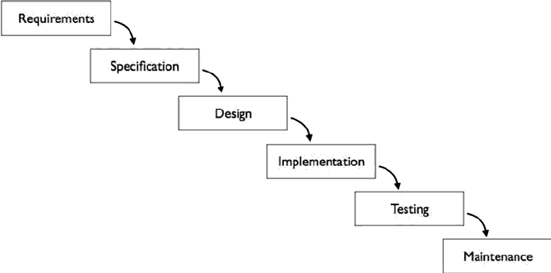

Source: researchgate.net

**2.3.2. System analysis and Design method**

For our project we will be using the structured system analysis design method (SSADM) which is a set of standards for systems analysis and application design that uses a formal methodical approach to the analysis and design of information systems. We will be using it to specify functional and nonfunctional requirement.

**2.3.4. Tools and languages used in implementation**

**2.4.1 HTML:**

Hypertext Markup Language (HTML) is the standard markup language for creating web pages and web applications. With Cascading Style Sheets (CSS) and JavaScript, it forms a triad of cornerstone technologies for the World Wide Web.

**2.4.2 CSS**

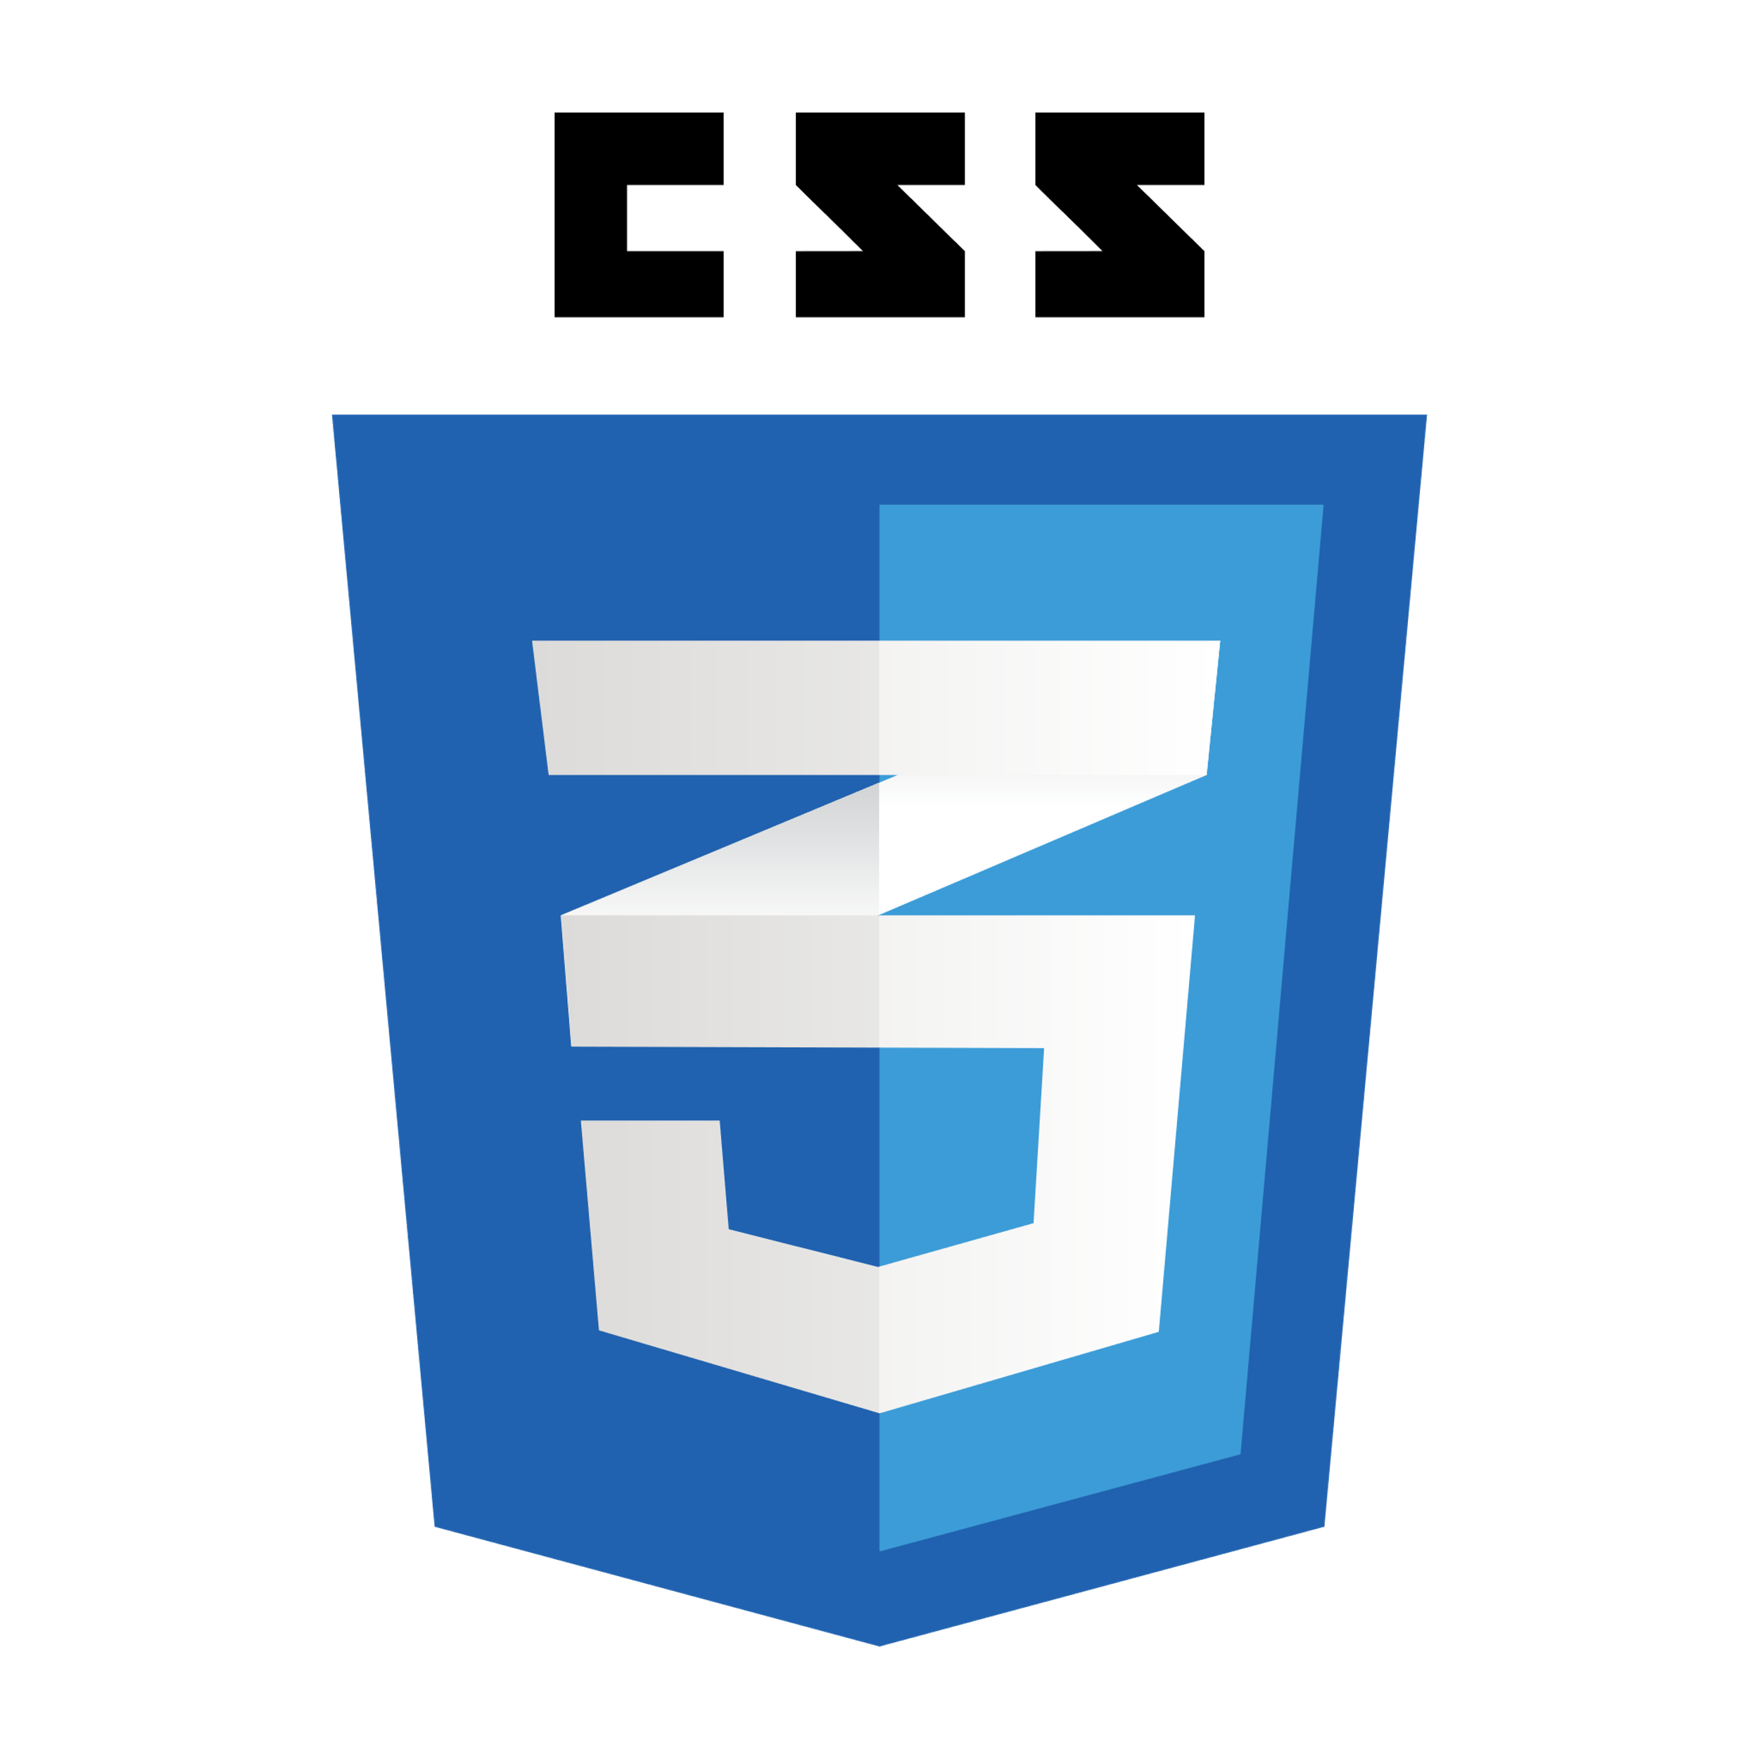CSS stands for Cascading Style Sheets CSS, it describes how HTML elements are to be displayed on screen, paper, or in other media. **CSS** is a computer language for laying out and structuring web pages (HTML or XML).

**2.4.3 JavaScript**

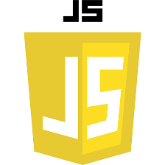JavaScript often abbreviated as JS, is a high-level, interpreted programming language. It is a language which is also characterized as dynamic, weakly typed, prototype-based and multi paradigm.

**2.4.4 XAMPP**

 XAMPP is a free and open-source cross-platform web server solution stack package developed by Apache Friends, consisting mainly of the Apache HTTP Server, Maria DB database, and interpreters for scripts written in the PHP, and Perl programming language.

**2.4.4.a PHP**

PHP is a recursive acronym for "PHP: Hypertext Preprocessor". PHP is a server-side scripting language that is embedded in HTML. It is used to manage dynamic content, databases, session tracking, even build entire e-commerce sites.

**2.4.5 Adobe Photoshop and Adobe illustration**

 Adobe Photoshop (Ps) is a raster graphics editor developed and published by Adobe Systems for Mac OS and Windows.

 Adobe illustrator (AI) it’s one of the most power graphic editor or app to design graphics and chart

**2.4.6 Nodes**

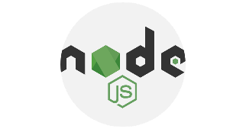Node.js is an open-source, cross-platform, back-end, JavaScript runtime environment that executes JavaScript code outside a web browser. Node.js lets developers use JavaScript to write command line tools and for server-side scripting—running scripts server-side to produce dynamic web page content before the page is sent to the user's web browser. Consequently, Node.js represents a "JavaScript everywhere" paradigm,[6] unifying web-application development around a single programming language, rather than different languages for server- and client-side scripts

**Expressjs**

Expressjs is a Nodejs web application server framework, which is specifically designed for building single-page, multi-page, and hydride web application. Expressjs is the backend part of something known as the MEAN stack. The MIT License is a permissive free software license originating at the Massachusetts Institute of Technology (MIT)[5] in the late 1980s. As a permissive license, it puts only very limited restriction on reuse and has, therefore, high license compatibility.

The MIT license is compatible with many copy left licenses, such as the GNU General Public License (GPL); MIT licensed software can be re-licensed as GPL software, and integrated with other GPL software, but not the other way around. The MIT license also permits reuse within proprietary software, provided that either all copies of the licensed software include a copy of the MIT License terms and the copyright notice, or the software is re-licensed to remove this requirement. MIT-licensed software can also be re-licensed as proprietary software, which distinguishes it from copy left software licenses. As of 2020, MIT was the most popular software license found in one analysis, continuing from reports in 2015 that MIT was the most popular software license on GitHub, ahead of any GPL variant and other free and open-source software (FOSS) licenses.

**MySQL**

MySQL is an open-source relational database management system (RDBMS).[5][6] Its name is a combination of "My", the name of co-founder Wideness’s daughter,[7] and "SQL", the abbreviation for Structured Query Language. A relational database organizes data into one or more data tables in which data types may be related to each other; these relations help structure the data. SQL is a language programmer uses to create, modify and extract data from the relational database, as well as control user access to the database. In addition to relational databases and SQL, an RDBMS like MySQL works with an operating system to implement a relational database in a computer's storage system, manages users, allows for network access and facilitates testing database integrity and creation of backups.

**Body-parser**

Body-parser middleware in Node.js

Last Updated: 13-05-2020

Body-parser is the Node.js body parsing middleware. It is responsible for parsing the incoming request bodies in a middleware before you handle it.

Installation of body-parser module:

You can visit the link to [Install body-parser module](https://www.npmjs.com/package/body-parser). You can install this package by using this command.

Source: *https://www.npmjs.com/package/body-parser*

After installing body-parser you can check your body-parser version in command prompt using the command. After that, you can just create a folder and add a file, for example, index.js. To run this file, you need to run the following command.

**Cors**

CORS is a node.js package for providing a [Connect](http://www.senchalabs.org/connect/)/[Express](http://expressjs.com/) middleware that can be used to enable [CORS](http://en.wikipedia.org/wiki/Cross-origin_resource_sharing) with various options. Cross-origin resource sharing (CORS) is a mechanism that allows restricted [resources](https://en.wikipedia.org/wiki/Web_resource) on a [web page](https://en.wikipedia.org/wiki/Web_page) to be requested from another [domain](https://en.wikipedia.org/wiki/Domain_name) outside the domain from which the first resource was served.

A web page may freely embed cross-origin images, [stylesheets](https://en.wikipedia.org/wiki/Style_sheet_(web_development)), scripts, [iframes](https://en.wikipedia.org/wiki/HTML_element), and videos. Certain "cross-domain" requests, notably [Ajax](https://en.wikipedia.org/wiki/Ajax_(programming)) requests, are forbidden by default by the [same-origin security policy](https://en.wikipedia.org/wiki/Same-origin_policy). CORS defines a way in which a browser and server can interact to determine whether it is safe to allow the cross-origin request. It allows for more freedom and functionality than purely same-origin requests, but is more secure than simply allowing all cross-origin requests.

The specification for CORS is included as part of the [WHATWG](https://en.wikipedia.org/wiki/WHATWG)'s Fetch Living Standard. This specification describes how CORS is currently implemented in browsers. An earlier specification was published as a [W3C](https://en.wikipedia.org/wiki/World_Wide_Web_Consortium) Recommendation.

Source: *https://www.npmjs.com/package/cors*

**CONSOLA**

Elegant Console Logger for Node.js and Browser

Source: *https://www.npmjs.com/package/consola*

**2.4.8 Git and GitHub**

**GIT**

Git is the most commonly used version control system. Git tracks the changes you make to files, so you have a record of what has been done, and you can revert to specific versions should you ever need to. Git also makes collaboration easier, allowing changes by multiple people to all be merged into one source.

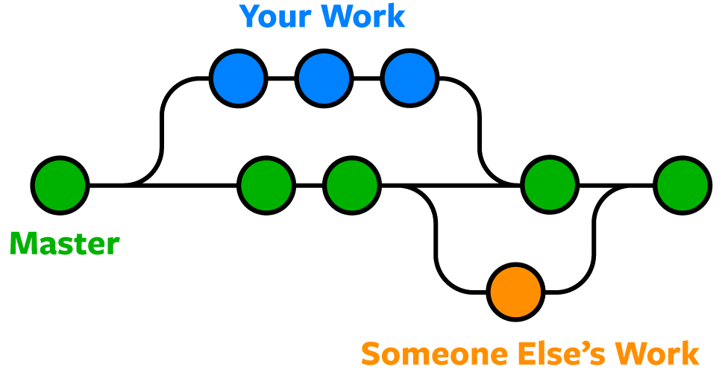

Source: [*https://www.nobledesktop.com/blog/what-is-git-and-why-should-you-use-it*](https://www.nobledesktop.com/blog/what-is-git-and-why-should-you-use-it)

Git is software that you can access via a command line (terminal), or a desktop app that has a GUI (graphical user interface) such as [SourceTree](https://www.sourcetreeapp.com/) shown below.

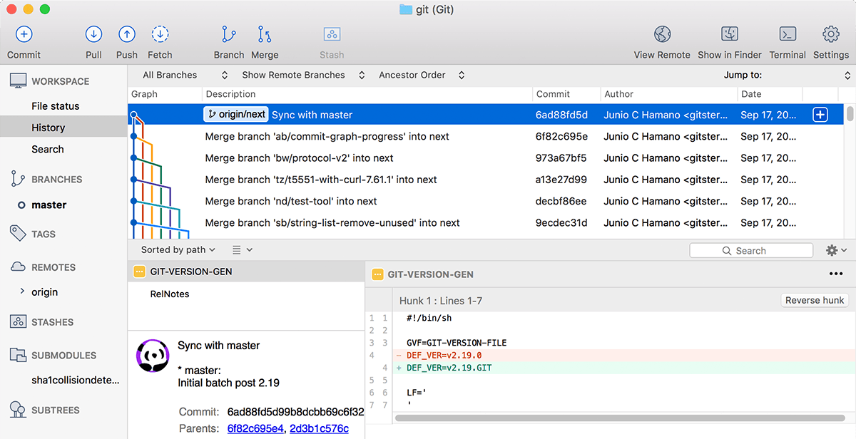

Source: [*https://www.nobledesktop.com/blog/what-is-git-and-why-should-you-use-it*](https://www.nobledesktop.com/blog/what-is-git-and-why-should-you-use-it)

**GitHub**

GitHub is a code hosting platform for version control and collaboration. It lets you and others work together on projects from anywhere.

Source: *https://guides.github.com/activities/hello-world*/

**2.4.9 Structured Query Language (SQL)**

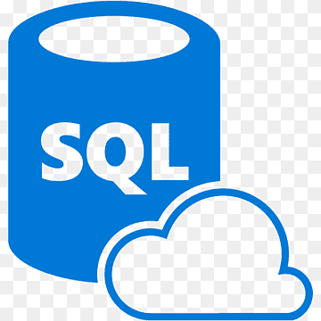SQL is a standard language designed for managing data in relational database management system. SQL stands for Structured Query Language. SQL is a standard programming language specifically designed for storing, retrieving, managing or manipulating the data inside a relational database management system (RDBMS).

Source: *https://www.tutorialrepublic.com/sql-tutorial/*

**2.4.9 Bootstrap**

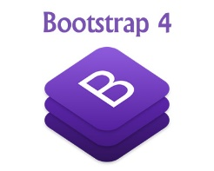Bootstrap is front-end web framework, which includes HTML, CSS, and SCSS based design templates for easier development.

**2.4.10 jQuery**

jQuery is a lightweight, "write less, do more", JavaScript library. The purpose of jQuery is to make it much easier to use JavaScript on your website. jQuery takes a lot of common tasks that require many lines of JavaScript code to accomplish, and wraps them into methods that you can call with a single line of code.

Source: *https://www.w3schools.com/jquery/jquery_intro.asp*

**2.4.11 SQL Injection**

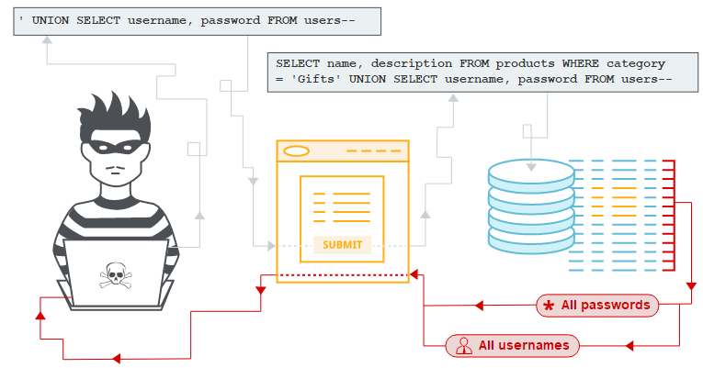SQL injection is a web security vulnerability that allows an attacker to interfere with the queries that an application makes to its database.

Source: *https://portswigger.net/web-security/sql-injection*

**2.5 DATABASE NOTIONS**

**2.5.1. Data**

data is information processed or stored by a computer. This information may be in the form of text documents, images, audio clips, software programs, or other types of data.

Source: *https://techterms.com/definition/data*

**2.5.2. Database**

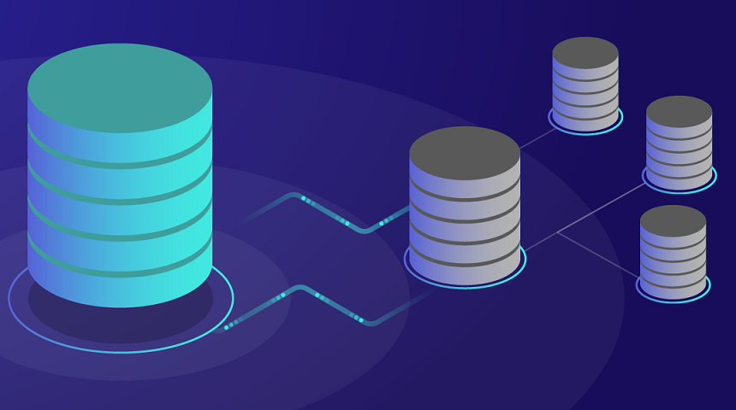

A database is an organized collection of structured information, or data, typically stored electronically in a computer system. ... The data can then be easily accessed, managed, modified, updated, controlled, and organized. Most databases use structured query language (SQL) for writing and querying data.

**2.5.3 Database management system (DBMS)**

Database management system (DBMS) is system software for creating and managing databases. The DBMS provides users and programmers with a systematic way to create, retrieve, update and manage data.

**2.5.4 Records in database management systems**

A record is a complete set of information. Records are composed of field, each of which contains one item of information.

**CHAP 2: METHODOLOGY**

**2.3.1 METHODOLOGICAL APPROACH**

Achieving such a scientific work is not in a blink of eyes, it results from research methodology and techniques.

**2.3.1 Data collection methodology**

During the development of this project, we use the “Structure Systems Analysis and Design

Methodology (**SSADM**)”.

**2.3.2 Data collection Techniques**

To get data collected, we have used observation, interview and documentation.

* **Interview**

The nature of this work requires meeting with daily users of secured doors depending on the places where they apply it. Interviews will be done with them to acquire more information depending on their experiences.

* **Technique of documentation**

In order to conduct our research, documentation technique has been used for consulting a wide variety of documents such as different e-books, websites for documentation.

* **Techniques of observation**

According to N. MULUMBATI (1980:26): “*observation is the most important, technique used by researchers to collect data. Nothing can replace a researcher’s direct contact with his domain and no other technique can enable a researcher in gathering more idea than observation technique*”.

This technique of research concerns the planned watching, recording and analysis of observed behavior as it occurs in a natural setting in observing, we have been able to understand the functionality of the earlier system.

**2.3.3 Software development methodology**

In this step, we are going to use a SDLC which is the process used by the software industry to

design, develop and test high quality software. The SDLC aims to produce high quality software that meets or exceeds customer expectations, reaches completion within times and cost estimation.

The following figure is a graphical representation of the various stages of a typical SDLC.

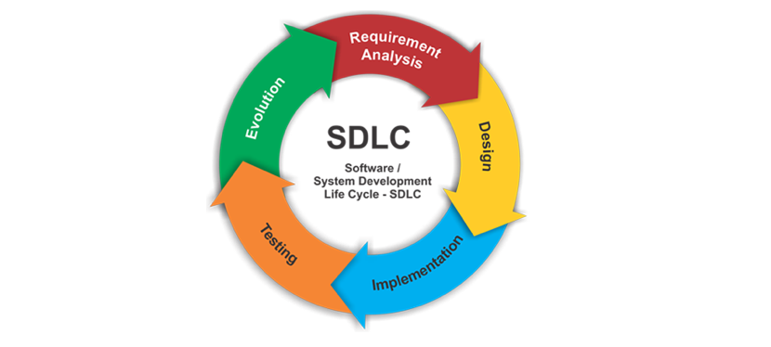

**Figure 1. System Development Life Cycle (SDLC)**

*Source: From Tutorialspoint.com*

***Stage 1: Planning and Requirement Analysis***

Requirement analysis is the most important and fundamental stage in SDLC it’s performed by the senior members of the team with inputs from the customer, the sales department, market surveys and domain experts in the industry. The planning for the quality assurance requirements and identification of the risks associated with the project is also done in the planning stage.

***Stage 2: Defining Requirements***

Once the requirement analysis is done the next step is to clearly define and document the product requirements and get them approved from the customer or the market analysis. This is done through an SRS (Software Requirement Specification) document which consists of all the product requirements to be designed and developed during the project life cycle.

***Stage 3: Designing the product Architecture***

SRC is the reference for product architects to come out with the best architecture for the product to be developed.

***Stage 4: Building or developing the product***

In this stage of SDLC the actual development starts and the product is built. The developers must follow the coding guidelines defined by their organization and programming tools like compilers, interpreters, debuggers, etc. are used to generate the code.

***Stage 5: Testing the product***

This stage is usually a subset of all the stages as in the modern SDLC models, the testing

activities are mostly involved in all the stages of SDLC.

***Stage 6: Deployment in the Market and Maintenance***

Once the product is tested and ready to be deployed it is released formally in the appropriate market

**CHOICE OF THE SDLC MODELS**

There are various software development life cycle models defined and designed which are

followed during the software development process but the waterfall model is chosen for this project.

**II. 4.1 *Waterfall model***

Waterfall approach was the first SDLC model to be used widely in software engineering to

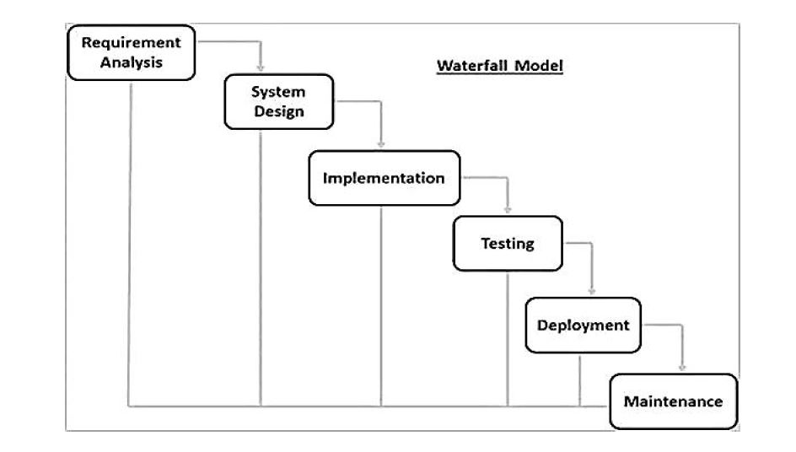ensure success of the project. In this model approach, the whole process of software development is decided into separate phases and the outcome of one phase acts as the input for the next phase sequentially.

**Figure 2. Waterfall model**

*Source: From Tutorialspoint.com*

The sequential phases in Waterfall model are*:*

* ***Requirement Gathering and analysis***: All possible requirements of the system to be

developed are captured in this phase and documented in a requirement specification

document;

* ***System Design***: The requirement specifications from first phase are studied in this phase and the system design is prepared. This system design helps in specifying hardware and system requirements and helps in defining the overall system architecture;
* ***Implementation***: With inputs from the system design, the system is first developed in

small programs called units, which are integrated in the next phase. Each unit is

developed and tested for its functionality, which is referred to as Unit Testing;

* ***Integration and Testing***: All the units developed in the implementation phase are

integrated into a system after testing of each unit. Post integration the entire system is

tested for any faults and failures;

* ***Deployment of system***: Once the functional and non-functional testing is done; the

product is deployed in the customer environment or released into the market;

* ***Maintenance***: There are some issues which come up in the client environment. To fix

those issues, patches are released. Also, to enhance the product some better versions are released. Maintenance is done to deliver these changes in the customer environment.

**Waterfall model advantages**

* Simple and easy to understand and use;
* Easy to manage due to the rigidity of the model. Each phase has specific deliverables

and a review process;

* Phases are processed and completed one at a time;
* Works well for smaller projects where requirements are very well understood;
* Clearly defined stages;
* Well understood milestones;
* Easy to arrange tasks;
* Process and results are well documented.

**CHAP 3. SYSTEM ANALYSIS AND DESIGN**

**3.1 INTRODUCTION**

In this chapter, we will focus on the structure and the design of our project, which deals with Restoration church Goma.

We will also be talking about the existing system of referencing or giving Christian news and information’s about restoration church in Goma city and showing some weaknesses of the existing system.

After the analysis of the existing system, we will be giving some problems with that system and we will also give a proposed system and the comparison of the two systems.

**3.2. ANALYSIS OF THE CURRENT SYSTEM**

**3.2.1. INTRODUCTION**

In Goma city the first way to inform Christians is to communicate it in church, is to run through church or to display the information’s in church, and until now there is no website or page that can display information about the restoration church.

The second way is too close to us, is about applications to notify all Christian’s users of the systems about new program and the program of the church.

**3.2.2. PROBLEM OF THE CURRENT SYSTEM**

Let us break down some problem with the existing system:

**1. Many churches do not have online page**.

Many churches in Goma city don’t have a platform to inform the Christians the only way they have is to print some flyers and distribute them in church or to put them in billboard on the way.

**2. Many Church with good services (the word of god) still not benefit to the Christian because of lack of connection with Christians.**

Some running church in the city are providing good services (the word of god) but still unknown because of the lack of interaction between them and the Christians in need of the services (the word of god).

**3. Strangers and tourists have nowhere they can find a substantial platform of running businesses of each wanted service.**

Many of tourists and strangers have a big challenge for finding wanted services because the existing systems just display only one category of businesses.

**3.3 ANALYSIS OF THE PROPOSED SYSTEM**

**3.3.1 Introduction**

Our proposed system is named “ANALYSIS, DESIGN AND IMPLEMENTATION OF RESTAURATION CHURCH INFORMATIONS SYSTEM” which is a system implemented in order to informs Christians about the church programs to be as the first way of interaction between the church and the Christians. In this part of the project, we will be showing the structure of our work and we will also show how it answered to the problem of informed the Christians across the city.

**3.3.2 Benefits of the proposed system over the existing system**

**1. Creating a common browser for running businesses**.

Among the aims of our work, this fact is also important: Finding all wanted businesses in one place. Goma business browser will be having as a general website where every business location () is available.

**2.** **Providing a business browser which covers many categories.**

As we have shown above the existing applications don’t have many categories of businesses included, but in this proposed system we have tried to merge different categories in order to get a very large business browser.

**3. Providing updated information of the registered business.**

Our matter is not only giving information of different businesses, but also to frequently update this information in order to do something more significant.

**3.4. METHODOLOGICAL APPROACH**

Methodology is a formal development process that defines a set of activities, methods, practices,

deliverables and automated tools that are used by developers and projects managers to

implement and maintain information systems.

**3.4.1 Structured system analysis and design**

Structured systems analysis and design methodology (SSADM) is a set of standards for systems analysis and application design that uses a formal methodical approach to the analysis and design of information systems. SSADM follows the waterfall life cycle model starting from the feasibility study to the physical design stage of development. One of the main features of SSADM is the intensive user involvement in the requirements analysis stage.

**3.4.2 Data collection techniques**

In order to achieve the success of this work, we have used some techniques which help us to achieve the aim of this dissertation.

The techniques used are “Documentation”, “interview” and “observation”.

* **Documentation technique**

This technique allows the researcher to consult books, memories, class notes and search some documents on internet that are related to his work.

* **Interview**

In this research the interview technique has been used as data collection technique, it consisted of the conversation between the researcher and the person holding some key information.

* **Observation**

Observation is a systematic data collection approach. Researchers use all of their senses to examine people in natural settings or naturally occurring situations.

**3.4.2. Software Development Process Model**

The development models are the various processes or methodologies that are being selected for the development of the project depending on the project’s name objectives. Many developments life cycle has been developed to allow people to reach different objectives. In our work we have used the waterfall model.

**3.5. System requirements**

In system requirement, there is functional requirement and non-functional requirement.

**3.5.1. Functional requirements**

A functional requirement in software engineering defines a function of a software system or its component.

A function is described by a set of inputs, behavior and outputs. They may be calculations, technical details, data manipulation and processing and other specific functionalities that define what a system is supposed to accomplish.

These are the specific functions that the system performs during execution:

* The system shall be able to save different information of business.
* The system shall be able to keep and alter the saved information.
* The system shall be able to search business by category or by name.
* The system will allow the admin to create, to alter, to update information of different business.

**3.5.2 Non-functional requirements**

The non-functional requirements can be said as system quality or system behavior over the specific functions.

The non-functional requirements of the system are:

* Interactive: the system will be responding to the user.
* Flexibility: the system will be usable in computer even in mobile phones.
* Availability: the system should be available at anytime and anywhere.
* Performance: the system will be executing with speed and without any interruption.

**3.6. DESIGN OF NEW SYSTEM**

**3.6.1. Function Diagram**

The Function Block Diagram (FBD) is a graphical language for programmable logic controller design that can describe the function between input variables and output variables.

**3.6.2 Data flow diagram**

A data-flow diagram (DFD) is a way of representing a flow of a data of a process or a system (usually an information system). The DFD also provides information about the outputs and inputs of each entity and the process itself.

Data flow diagram have four symbols that make it useful for communication between analysts and users, it shows the data used and provide by process within a system, data flow diagram makes use of four basic symbols which are create structural analysis, information flow, process oriented, data process diagrams and data flowcharts (Paul smith 2000).

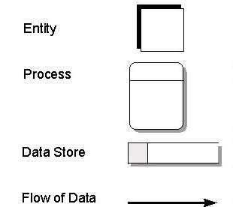

*Source: Pittsburgh.Edu*

**External entity**: an external entity is a source of dataflow which is outside the area of study. Those entities which originate data are represented on business process diagram.

**Process**: A process shows transformation of data flows within the system. The symbol use is a rectangular box as you can see the image above; it helps to identifier number appears in the left-hand corner. This is allocated arbitrary at the top level and serves as unique reference.

It helps to allocation appears to the right of identifier and describes where in the system the process takes place. This may be a department or piece of hardware. Finally, a descriptive title is placed title placed in the center of the box. This should be a simple imperative sentence with a specific verb for maintain customer records.

**Data store**: a data store is holding place for information within the system. Data store is represented by on open-ended narrow rectangle. It may be long-term files such as sales ledgers or may short term accumulations batches of documents that are waiting to be processed. Each data store should be given reference followed by an arbitrary number.

**Resource flow**: it shows the flow of nay physical material from its source to its destination. For this reason, they are sometimes referred to as physical flows. The physical material is a question should be given meaningful name. resource flow is usually restricted early, high level diagrams and are description of the physical flows of materials is considered to be important to help the analysis.

**MODULES**

1. **Christians (users):** when user open our website if a new user, he/her must login or create an account he/her don’t have it.
2. **Christians:** A user can see his information, his account information he can edit them.
3. **Programs:** users are allowed to see programs if there are log in,
4. **Admin:** an admin is allowed to create a user, read user, update user, and delete user.
5. **Admin:** and have authorizations to see requests, to reply to those people whom those requests, his allowed to delete request.
6. **Admin:** admin can add programs, edit it, update it and delete it.
7. **Admin:** he/her may add news and make a (CRUD) to it.
8. **Admin:** admin can add pastors, and he/her allowed to make a (crud) to them.
9. **Admin:** admin can record wedding, can edit wedding, he can edit and delete it also.

*Crud (Create Read Update and Delete)*

**CHAP 4. SYSTEM IMPLEMENTATION**

Systems implementation is the process of: defining how the information system should be built (i.e., physical system design), ensuring that the information system is operational and used, ensuring that the information system meets quality standard (i.e., quality assurance). Our project is a website analysis, design and implementation of restoration church information system.

Here below is the home page that display our information and allow user to login if they have an account if not, they have to sign up or create an account. Within this home page we tried to put all information about our church and what we did.

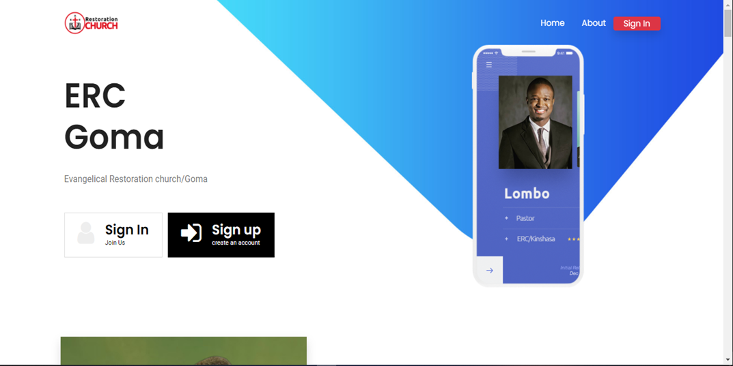

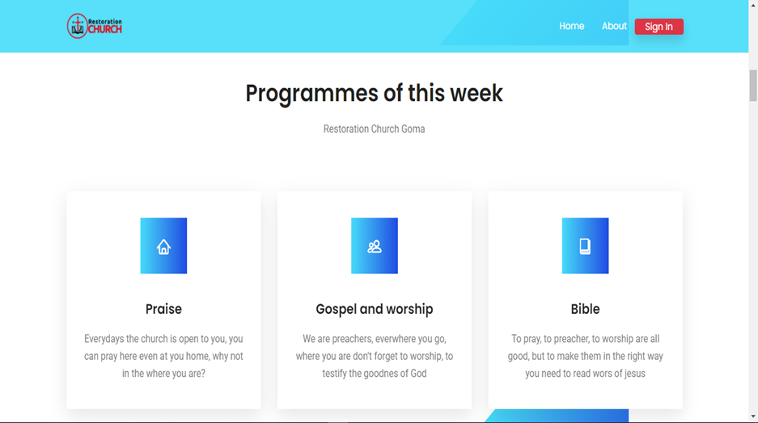

At this level the system shows what we are caring on. Praise, gospel and worship and reading the bible. This is the Christian life.

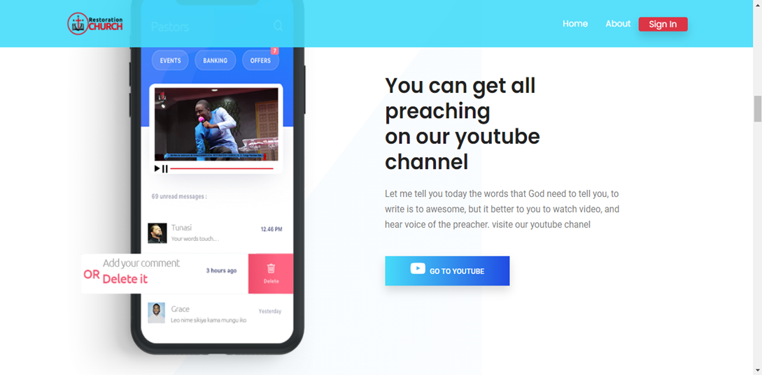

Here we are sharing our youtube link. We choose to store our videos from youtube because they have a big size of storage and they are secure. When the user link to this button he/her will have a new tab on his screen browser and be redirect to our youtube channel

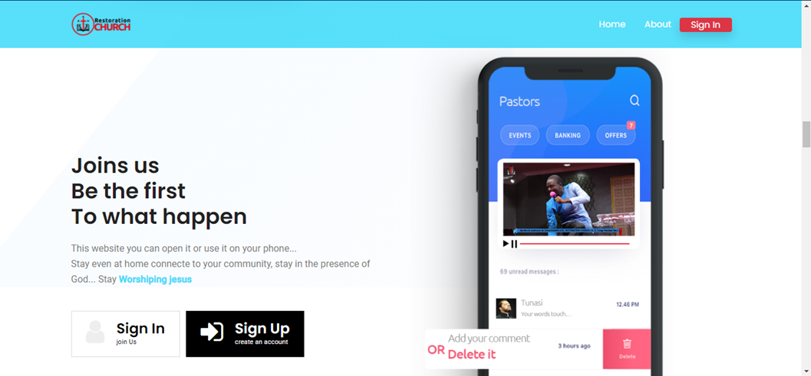

This UI show our mobile app. Which is not implement yet and it’s a recommendation from those whom will come to implement this app.

There is two important buttons, the first one it the sign In button where to login into the system, and last one is the sign up button

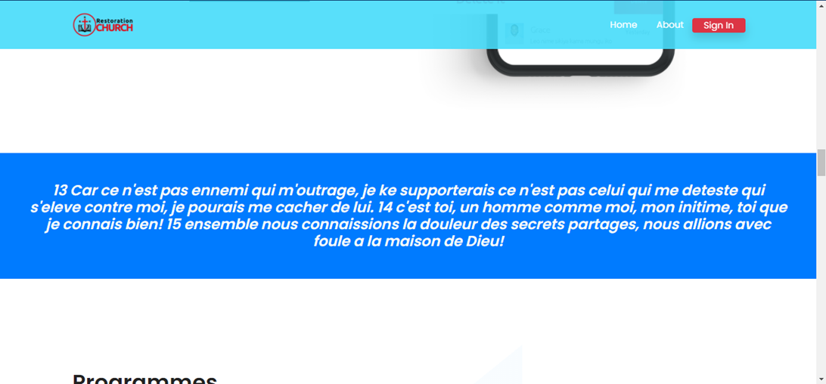

The verset of the day. This word is coming from the database. Mean every day the website or the system will display new word of the bible.

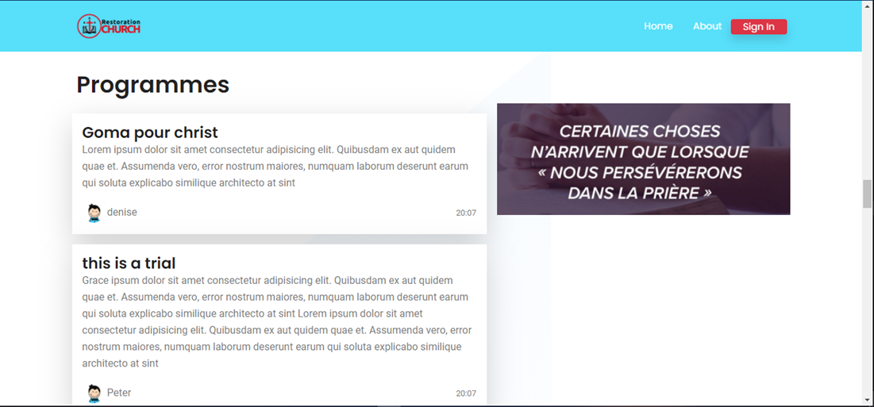

Now it places of the programs of the main target of our system is to make Christians informed even if they are at home, job or whatever. The programs should help Christians to be online information in real time. When there is a new program the system will notify them.

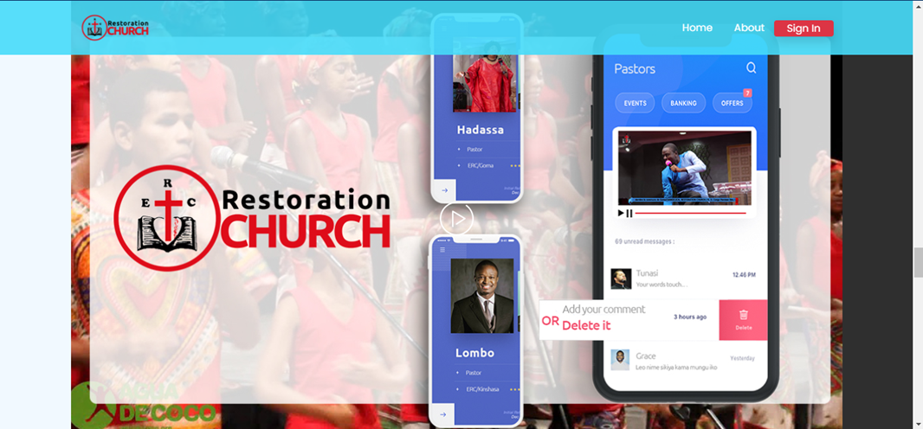

This works links this link above but this one allows users to get only the video of our YouTube channel and they are allowed to watch it in their devices. Everywhere, anytime. And inside the image show you can see the information within a phone. it because our website is responsive it can be useable in every kind of device which have browser and internet access.

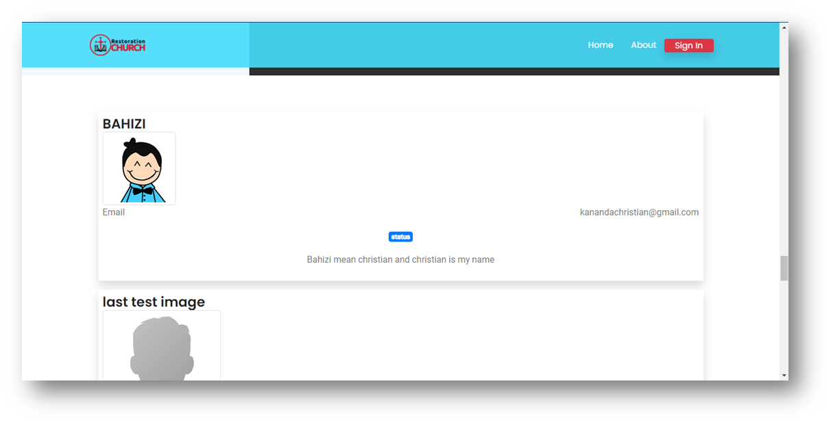

The system displays only five (5) last users. In order to call others to join the community.

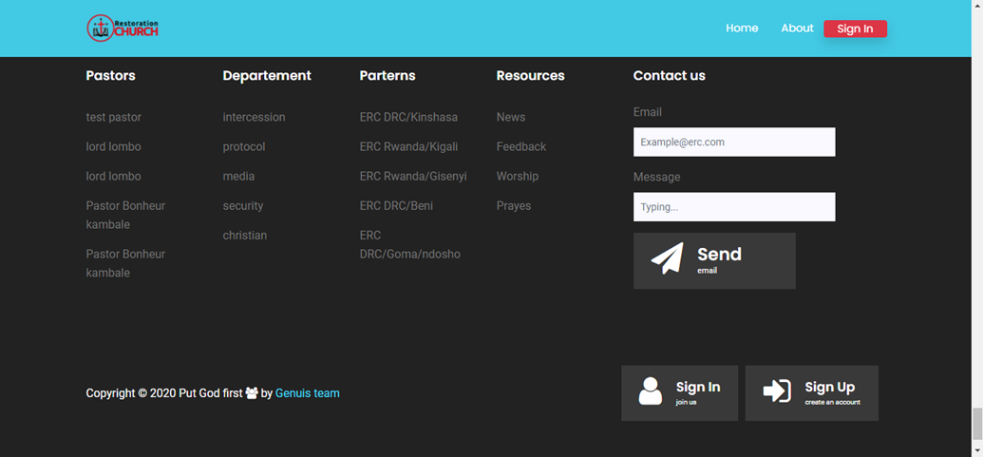

The footer of our index page. This footer displays 5 pastors, all departments and patterns of our church, and resources news feedback within users and administration of the restoration church. And we call people also to join our community (platform) by sign in or signup. The form above the top right is to send the request to the database.

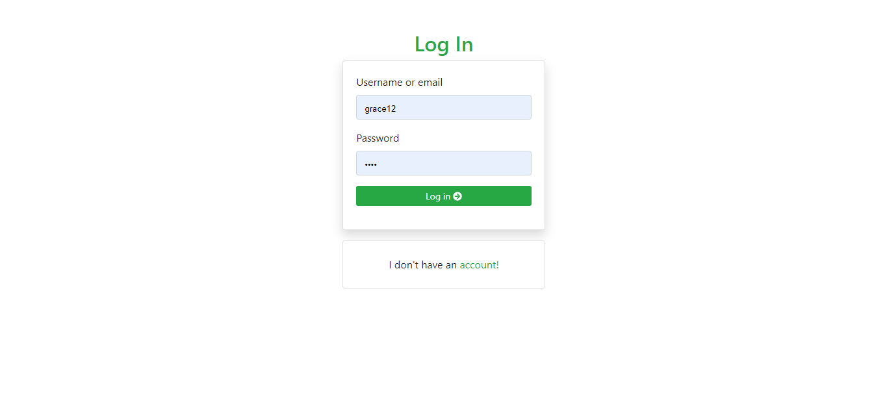

Our login page is use to both side of users, admin and simple users. The system is using MySQL database and then, when the users enter his email or username and password the system will check if the user level of that session if is 0 the user will be redirect to. /member side and if his user level is equal to 1, he will be redirect to. /admin.

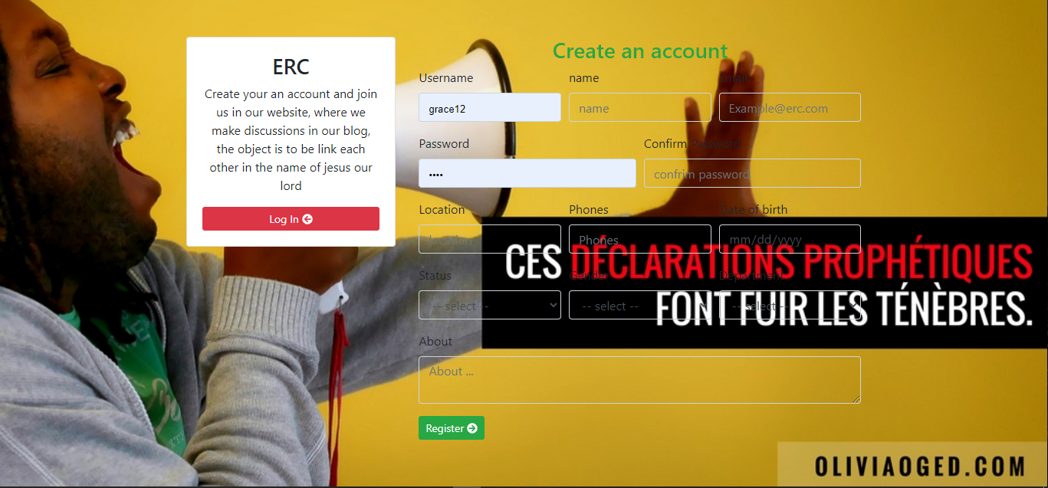

Registration. At this part our system allows users to create their account itself and others can be created by the administration of the church this is because we need on many people we have in our church and whom are external (guest). The account should have a unique email address and unique id. This allows us to identify user when we get request or bad message, information etc.…

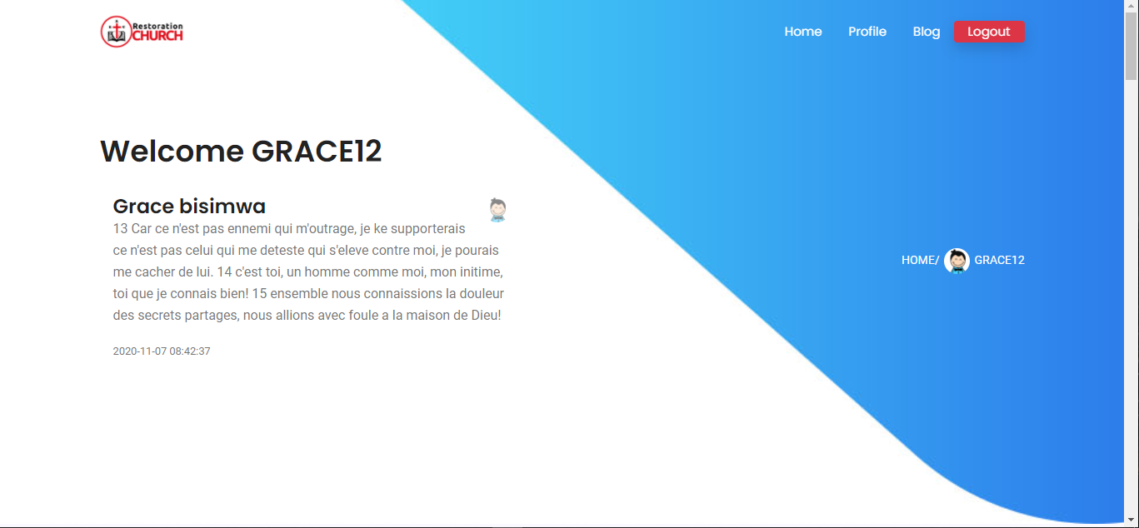

This the home page of the user. His greet by the system and this page is secured by the lock using php session and JavaScript. The local storage store data into his tables. In order to avoid the login in the next connection.

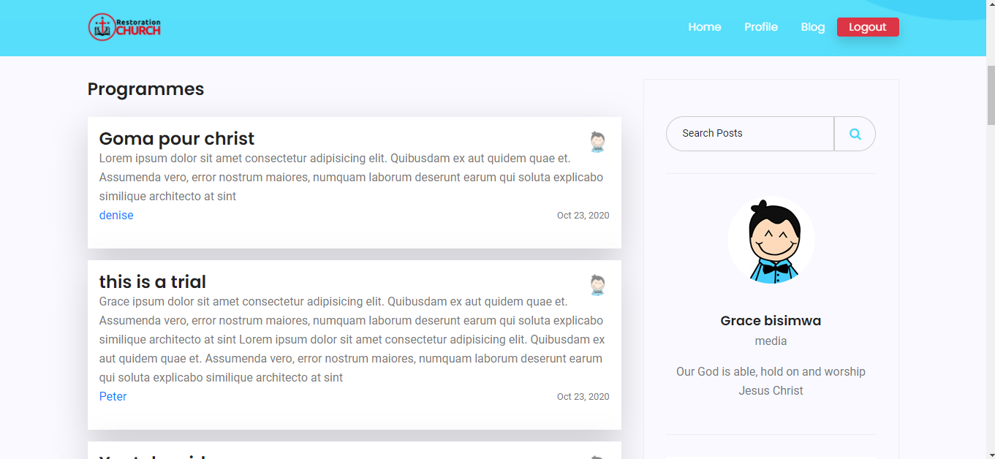

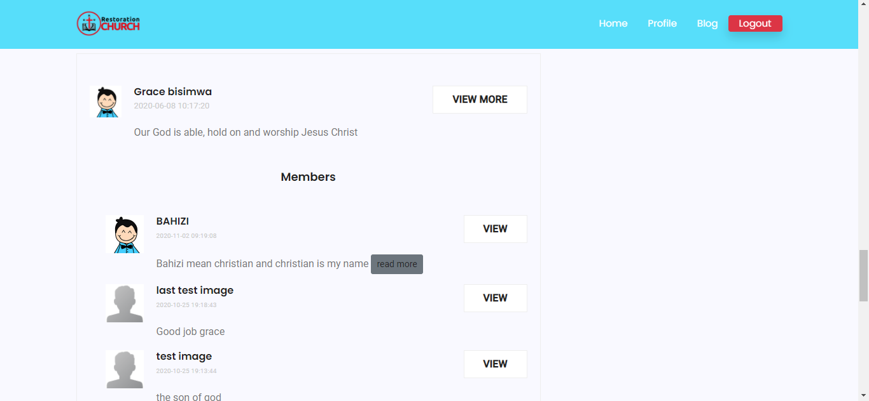

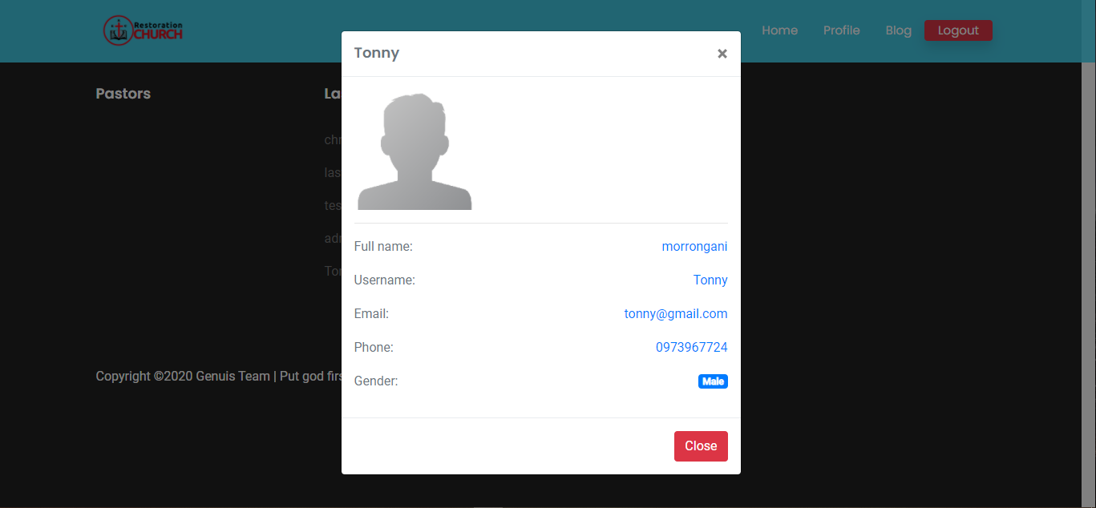

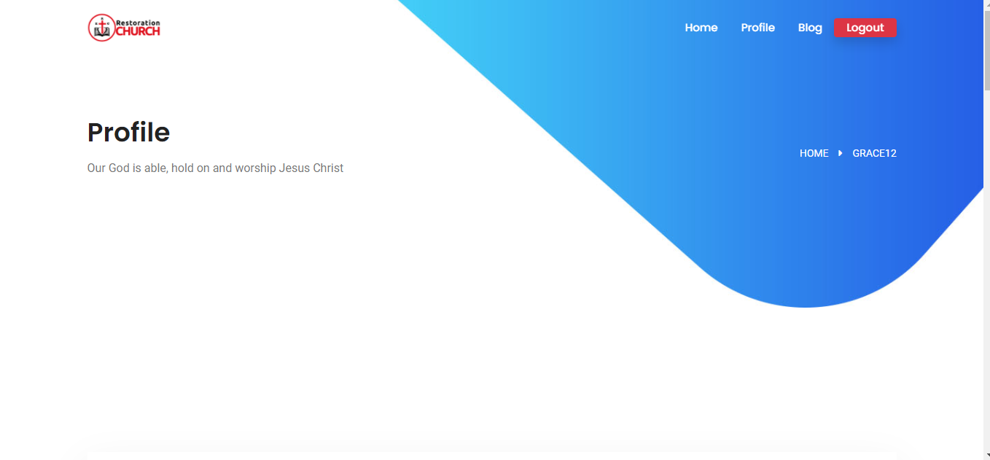

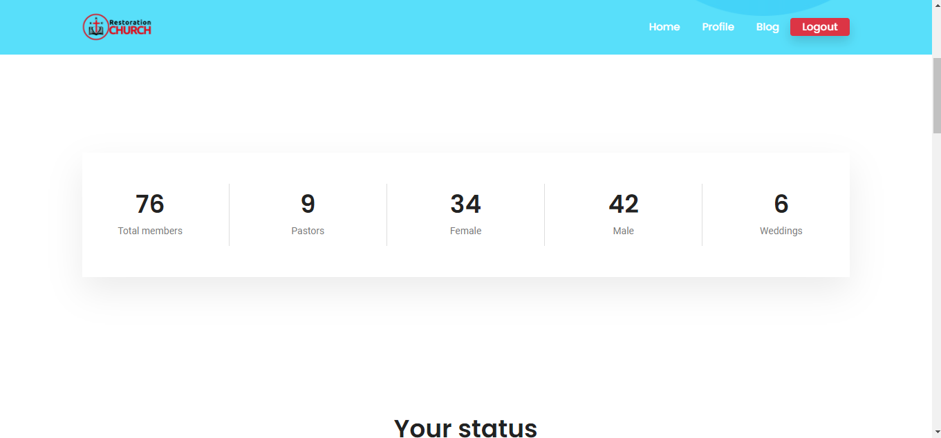

This interface shows the users in details about the members of the church, number of men and women, the total amount of member in our community, the number of weddings.

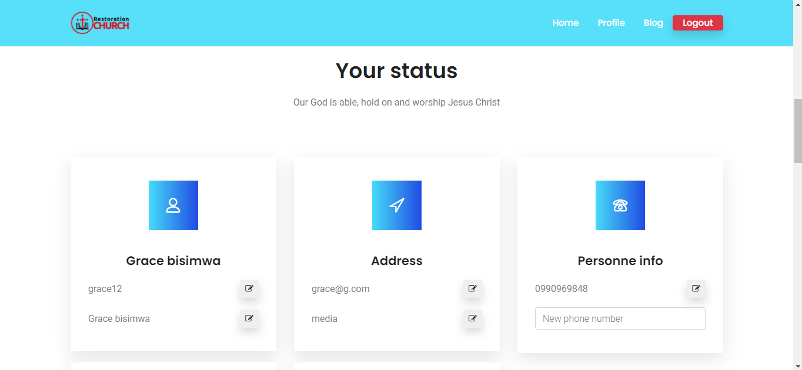

Everyone can make mistake, reason why we tried to create this part. Where a user can change his or her username, and others information for his/her account.

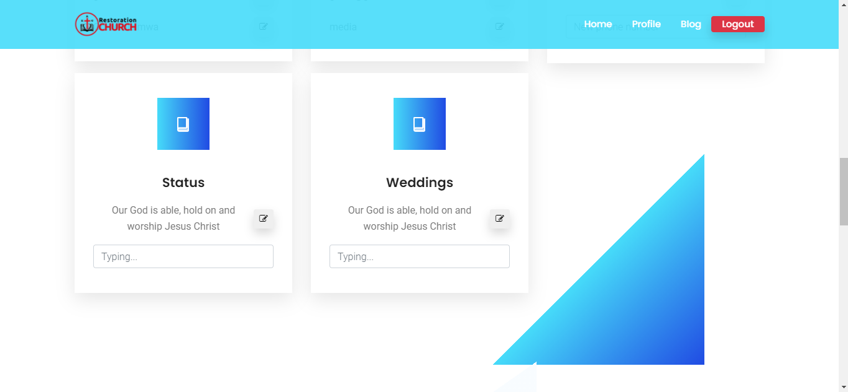

User can change also his/her status and his/her wedding status

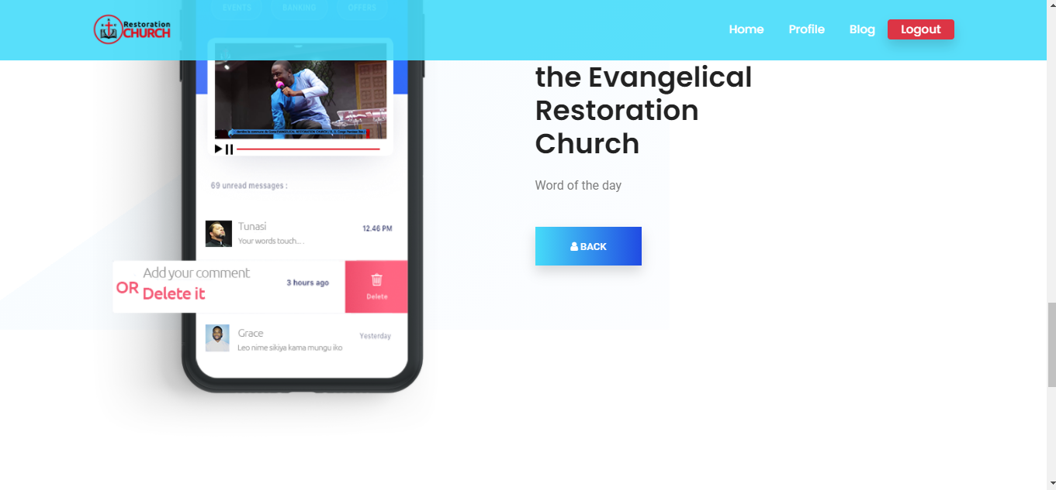

This interface shows or display our last video uploaded on YouTube channel. It can be preaching, or new, info, programs but the last one

**5.1 CONCLUSION**

**5.2 RECOMMENDATIONS**

For improvement of this work, we would like to give some recommendations. Our first recommendation of this work is to researchers especially for ones of Kigali Independent University/ Gisenyi campus, for improving by using more tools for interactions between the client and the seller and to take this as a starting point of them research.

**5.3. FUTURE WORK**